**Objective 1:** Set up the primary version of the web application in N.Virginia. Tasks:

I have created a VM named new VM in North Virginia 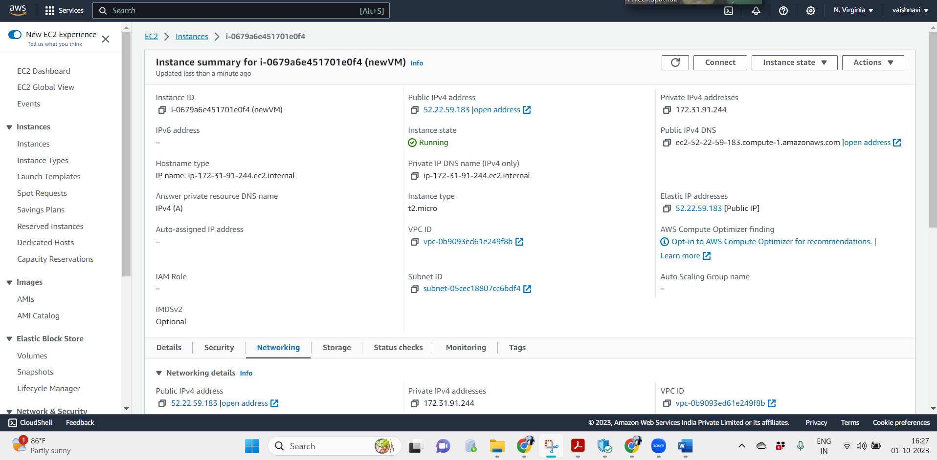

Associated with a elastic IP.

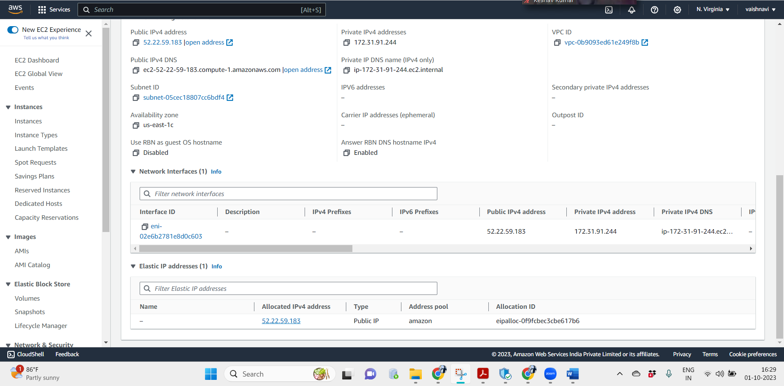

**Objective 2:** Establish a backup in Oregon to ensure high availability. - Tasks:

Created a new VM AMI image.

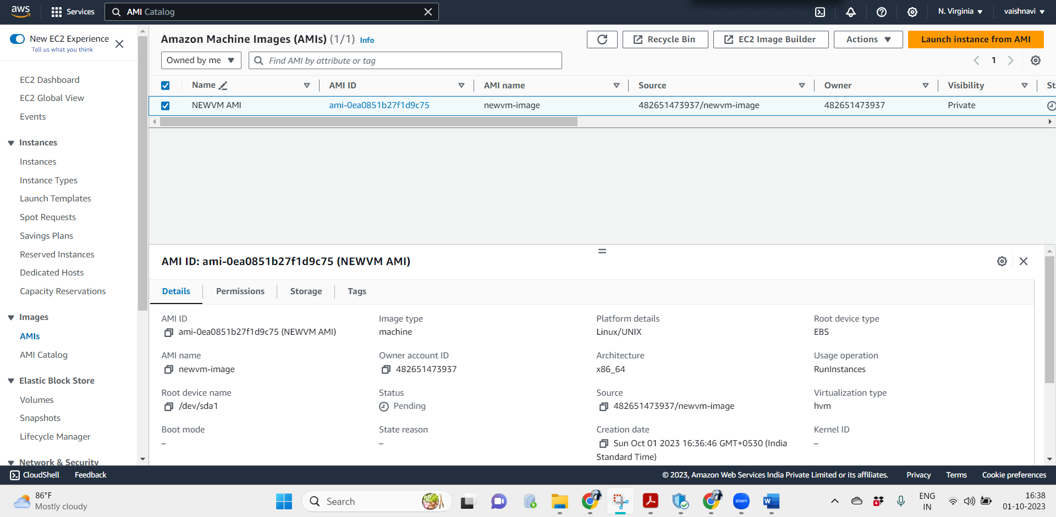

Copied the AMI to Oregon region.

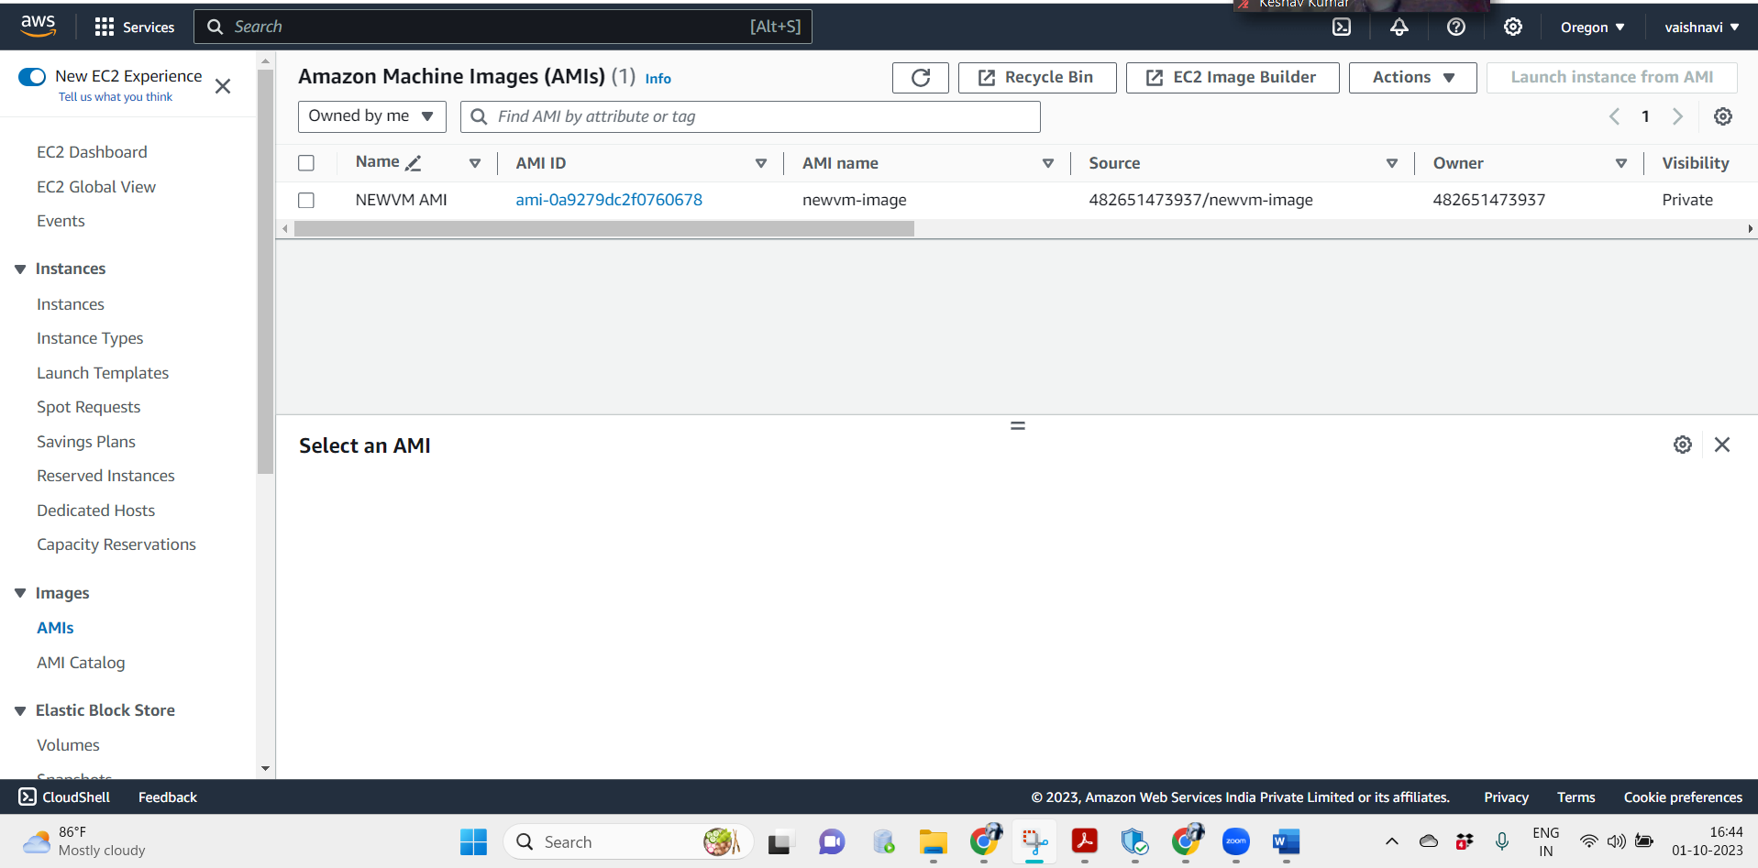

**Objective 3:** Set up an Amazon Elastic File System (EFS) for shared data storage. - Tasks:

Created efs in Virginia region

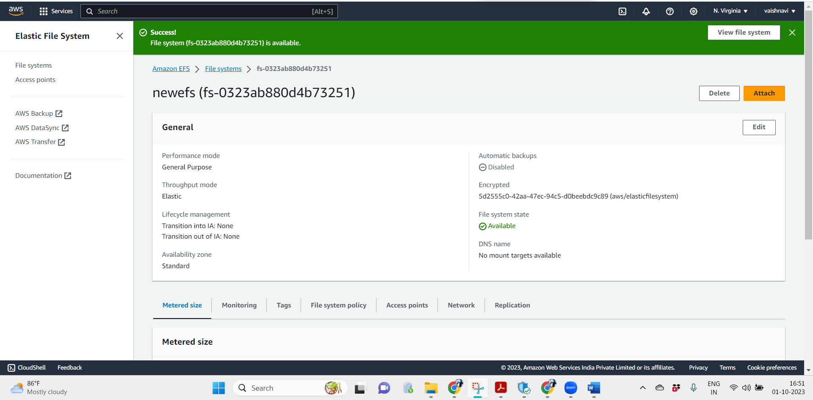

Launched VM using copied AMI in Oregon region

